1. **Problem Name:** A program that attempts to add an element at the end of an array.

**Problem Code & Output:**

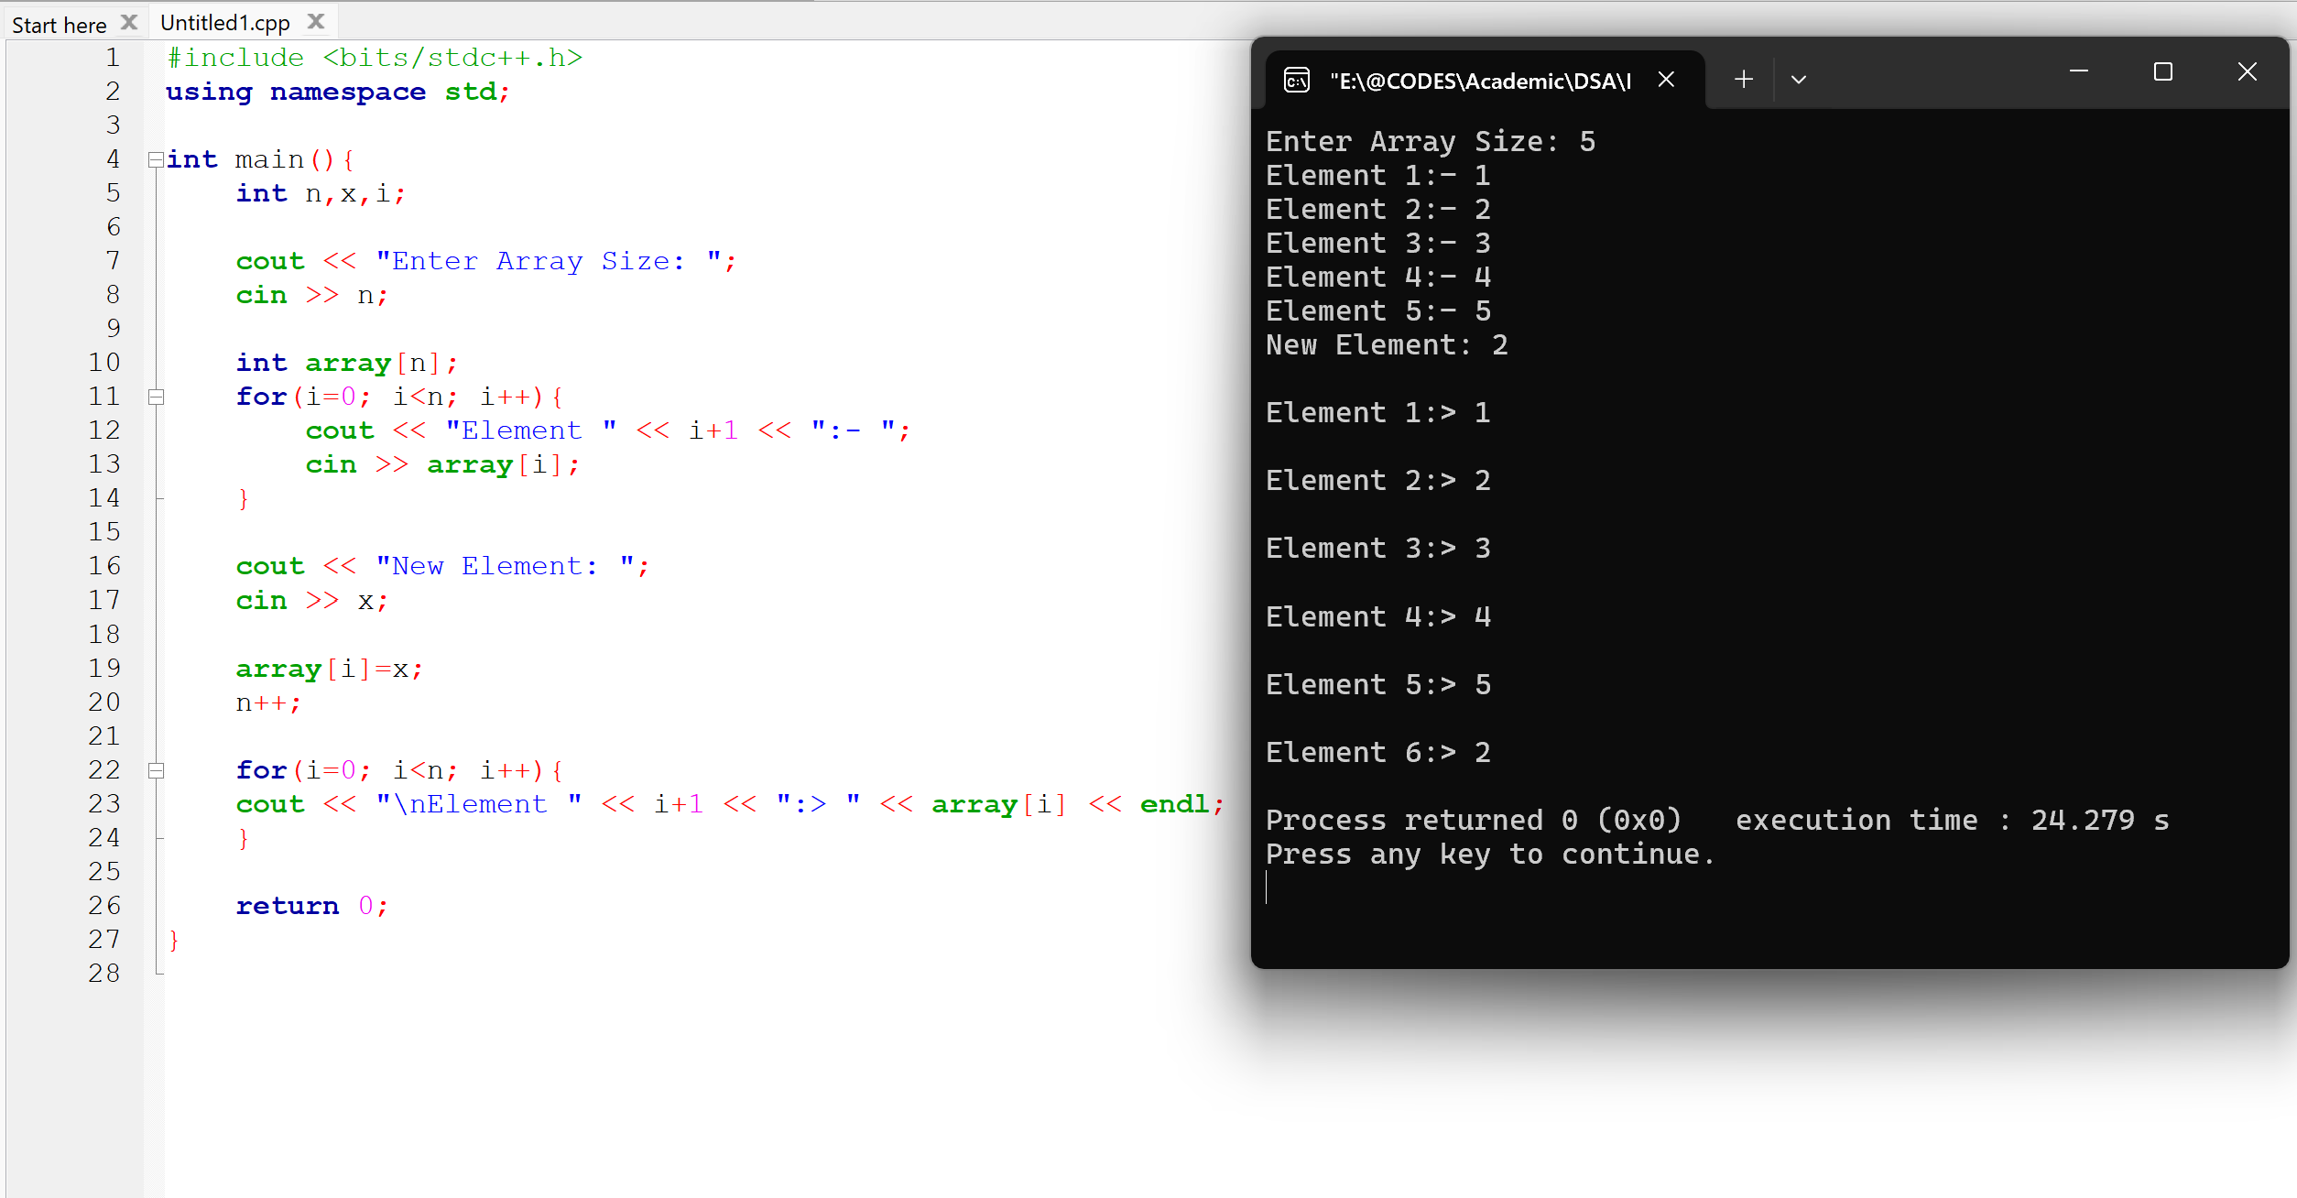

1. **Problem Name:** A program that allows adding multiple elements to the end of an array after its initial creation.

**Problem Code & Output:**

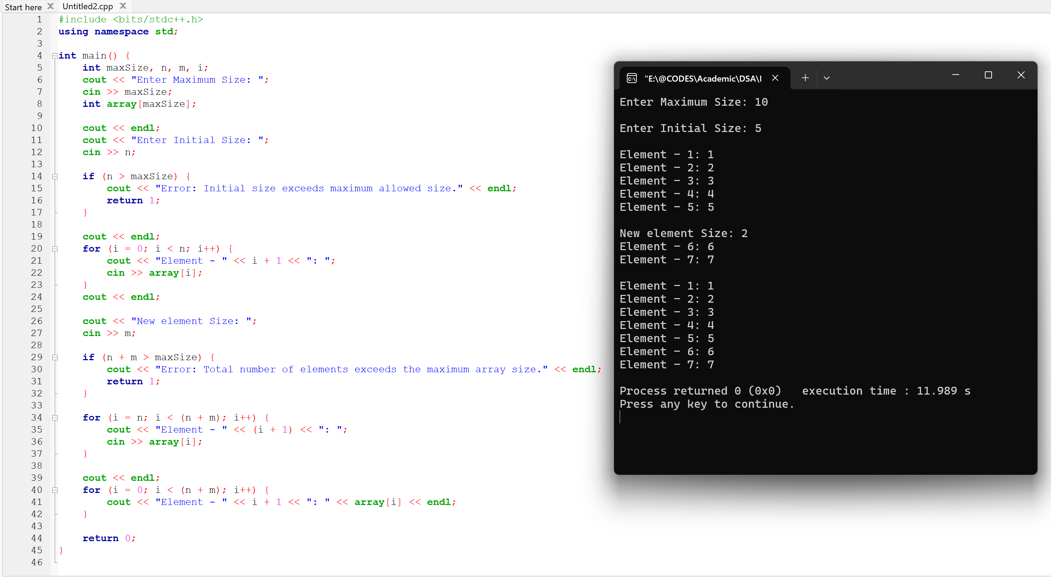

1. **Problem Name:** A program that performs a linear search to find an element in an array.

**Problem Code & Output:**

